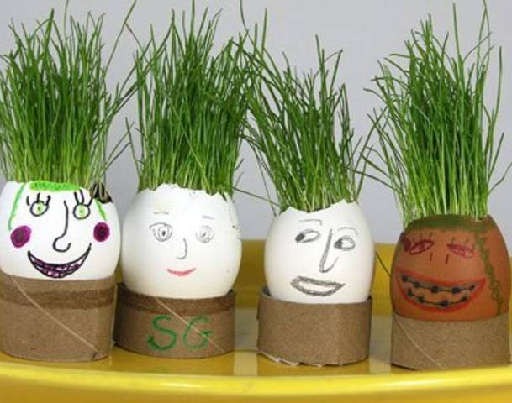
Eggheads
Materials Needed:
Empty eggshells, with tops carefully removed
Grass seed
Potting Soil
Holder –
Toilet Paper Tubes – cut into smaller rounds, Keurig style K-Cups (cleaned) or Small Paper Cups
Googlie eyes
Pipe Cleaners
Plastic Jewels
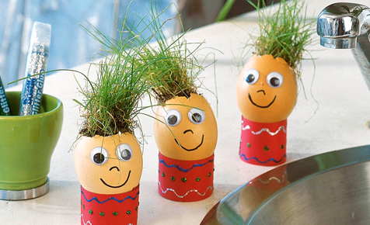
Sequins
Glue Sticks
Sharpie Markers
Plastic Spoons
Plant mister

Procedure:
- Choose an egg and a holder.

- Decorate your egg with a face and some crafty decorations (googlie eyes, sequins, markers, tissue paper, stickers) and decorate holder.

- Once you have finished decorating your egg (and it hasn’t cracked) put a small amount of dirt into the egg with a spoon. Fill about ¾ full with dirt.

- Sprinkle with grass seeds on top of the soil and water with the plant mister. Place egg in holder. Set aside and admire.

- Water your egghead lightly every day. If you water regularly, the grass will grow and look like hair.

